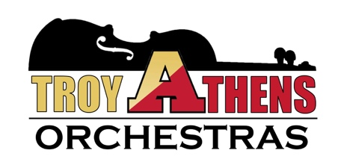

Symphony, Concert, and Freshman Orchestras
ATHENS ORCHESTRA PARENT ASSOCIATION __________________________________________________________________________________________
Mr. Ryan J. Quinn
Director of Orchestras, Athens High School
AthensOrchestas.com

February

Dear Future Orchestra Families,

Welcome to the next chapter of your child’s career in orchestra! My name is Mr. Ryan Quinn and I will be your child’s orchestra teacher at Athens High School. We have three ensembles here; Freshman, Concert, and Symphony Orchestras. Next year, your child will be performing in the Freshman orchestra. Any student wishing to audition for Symphony Orchestra is welcome to do so after their year in Freshman Orchestra. Every freshman continuing in orchestra as a sophomore is placed in Concert orchestra without an audition.
Our website is the treasure-trove of information. The website address is www.athensorchestras.com. Please bookmark this site, it has everything you will need as the year moves forward and gives you an in-depth look at the large scope of our program here. Check out our pictures and recordings there, too!
We begin every orchestra school year with our annual fall camp the first week back to school in September. More information will be posted on the website mentioned above; please continue to check it as we grow closer to the end of the school year. Every orchestra member attends camp and all say it is the highlight of their orchestra experience. We spend a musical weekend with clinicians, bonding and getting to know each other, and having fun. To know more and see pictures, please visit the website!
Please feel free to email me at rquinn@troy.k12.mi.us with any questions or concerns you may have. I look forward to working with your child in the next chapter of their music career!
Musically Yours,

Ryan Quinn, Director of Orchestras

